# 

# Project Report

# Advanced Programming Concepts (23CS007)

## BACHELOR OF ENGINEERING

***in***

## Computer Science and Engineering

#### Submitted by: Submitted to:

Anshika (2310990118) Mr. Venkatesh K

Bhavik Thakur (2310990142) Technical Trainer

Deewanshi Gujral (2310990152)

Devanshi Gupta (2310990153)

**CHITKARA UNIVERSITY, PUNJAB**

**CHANDIGARH-PATIALA NATIONAL HIGHWAY**

**RAJPURA (PATIALA) PUNJAB-140401 (INDIA)**

**INDEX**

|  |  |  |
| --- | --- | --- |
| **Practical No.** | **Practical Name** | **Page No.** |
|  | **Declaration** | 1 |
|  | **Acknowledgement** | 2 |
|  | **Introduction** | 3 |
|  | **Technology Stack** | 4 |
|  | **Key Features** | 5 |
|  | **Applications / Use Cases** | 6 |
|  | **System Snapshots** | 7-9 |
|  | **Future Scope** | 10 |
|  | **Conclusion** | 11 |

**DECLARATION**

We hereby declare that the project work titled, **"File Sharing Application"** submitted as part of Bachelor’s degree in CSE, at Chitkara University, Punjab, is an authentic record of our own work carried out under the supervision of **Mr. Venkatesh K**.

**Signature**

**ACKNOWLEDGEMENT**

It is our pleasure to be indebted to various people, who directly or indirectly contributed in the development of this work and who influenced my thinking, behavior, and acts during the course of my study.

We express our sincere gratitude to all for providing me an opportunity to undergo Integrated Project as part of the curriculum.

We are thankful to **Mr.** **Venkatesh K** for his support, cooperation, and motivation provided to us during the training for constant inspiration, presence, and blessings.

Lastly, we would like to thank the almighty and our parents for their moral support and friends with whom we shared our day-to-day experience and received lots of suggestions that improve our quality of work.

**Introduction**

The rapid growth of digital data has increased the demand for efficient, secure, and user-friendly file management systems. Existing file-sharing solutions often lack scalability, customization, and strong access control. To address these gaps, this project, **File Sharing Application**, offers a modern solution for managing, sharing, and securing digital files.

Developed using **React, Spring Boot, MongoDB, and Tailwind CSS**, the system integrates a responsive frontend with a robust backend to ensure seamless performance. Key features include uploading, previewing, downloading, deleting, and sharing files, with secure access enforced through **Clerk authentication**. Users can toggle file visibility, generate shareable links, and organize files using grid or list views.

By combining a clean architecture with modular design, this project demonstrates how full-stack technologies can be applied to build a scalable and professional-grade application suitable for real-world use. It not only strengthens practical knowledge of modern web development but also highlights best practices in security and user experience design.

**Background**

File sharing and cloud storage solutions have become essential in both personal and professional domains. Applications like Google Drive, Dropbox, and OneDrive dominate the market but may be overly complex or costly for small-scale projects or organizations. This project aims to design a **custom, scalable, and secure file manager** that balances simplicity with essential features. By using **MongoDB** for metadata management and **Spring Boot** for backend APIs, the system ensures reliability and performance. React with Tailwind CSS provides a responsive and modern frontend, making file organization and access intuitive.

**Objectives**

The project aims to develop a secure and efficient file management system where users can upload, preview, download, and delete files. It allows controlled sharing through public and private file visibility. Additionally, it provides a modern, responsive interface with React and Tailwind CSS, integrated with Clerk-based user authentication.

**Scope**

This File Manager Web Application can be used by individuals and organizations to securely store, manage, and share files online. It enables easy access to files from any device, ensures data privacy with user-based authentication, and supports controlled sharing through public/private visibility. The modular design allows future enhancements, such as adding collaborative features, cloud integration, or advanced search and tagging functionality.

**Technology Stack**

* **Frontend:**
  + **React.js** – For building a dynamic, responsive, and interactive user interface.
  + **Tailwind CSS** – For modern, utility-first styling and responsive design.
  + **Lucide Icons** – For clean and consistent iconography in the UI.
* **Backend:**
  + **Spring Boot –** For creating a robust REST API and handling business logic.
  + **Java –** Programming language used for backend development.
  + **Spring Security –** For authentication and authorization using JWT and Clerk
* **Database:**
  + **MongoDB –** NoSQL database for storing file metadata, user profiles, and transactions.
* **Other tools and Libraries:**
  + **Clerk Authentication** – For secure user-based login and identity management.
  + **Maven –** For project build and dependency management.
  + **Lombok –** To reduce boilerplate code in Java classes**.**

**Key Features**

* **File Upload & Management** – Upload, preview, download, and delete files with ease.
* **Public & Private File Visibility** – Toggle files between public and private modes for controlled sharing.
* **Secure User Authentication** – User-based access control using Clerk authentication and JWT tokens.
* **Responsive UI** – Modern, elegant interface with grid and list views using React, Tailwind CSS, and Lucide icons.
* **Credit-Based File Upload** – Limit uploads based on user credits to manage resource usage.
* **File Sharing** – Share public files via unique, shareable links.
* **Scalable Backend** – Spring Boot and MongoDB ensure efficient storage, retrieval, and future scalability.
* **Modular & Maintainable Code** – Clean separation of frontend and backend logic for easy maintenance.

**Applications / Use Cases**

* **Personal File Management:**

Users can securely upload, organize, and manage personal files such as documents, images, and videos in one place. Features like file preview, download, deletion, and controlled visibility ensure users have full control over their digital content. This helps users maintain a structured digital workspace and prevents loss of important files. The application also tracks file metadata, providing easy access and searchability.

* **Team Collaboration:**

Teams can share files among members or external collaborators using public links. Grid and list views, along with visibility toggling, help organize shared resources while keeping sensitive files secure. It facilitates efficient workflow by allowing multiple team members to access and edit shared files. Notifications and credit-based access help manage file usage within teams effectively.

* **Educational Use:**

Students, teachers, and institutions can upload and distribute study materials, assignments, and lecture notes. Public and private file modes make it easy to share class-wide resources while protecting confidential submissions. Teachers can manage and monitor student submissions securely, while students can submit and retrieve their work efficiently. The platform also supports organizing files by subject, topic, or course for easy retrieval.

* **Secure File Sharing for Businesses:**

Organizations can manage business documents like reports, presentations, and confidential files. User-based access control, shareable links, and scalable storage ensure secure and efficient file management within teams. This reduces dependency on email attachments or third-party file-sharing services. Additionally, it ensures regulatory compliance and data security for sensitive corporate information.

**System Snapshots**

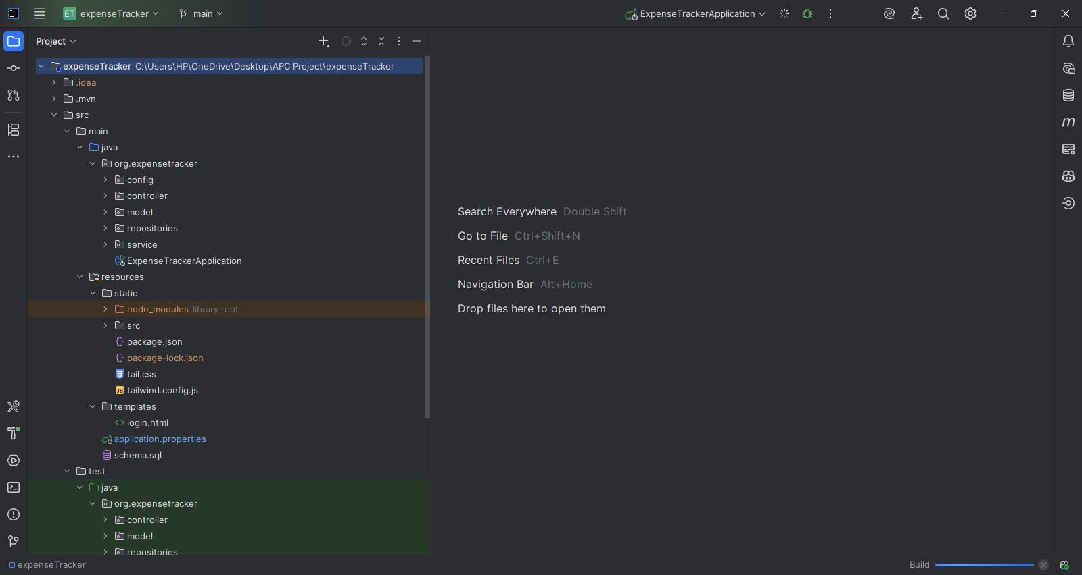**Fig : Project Structure**

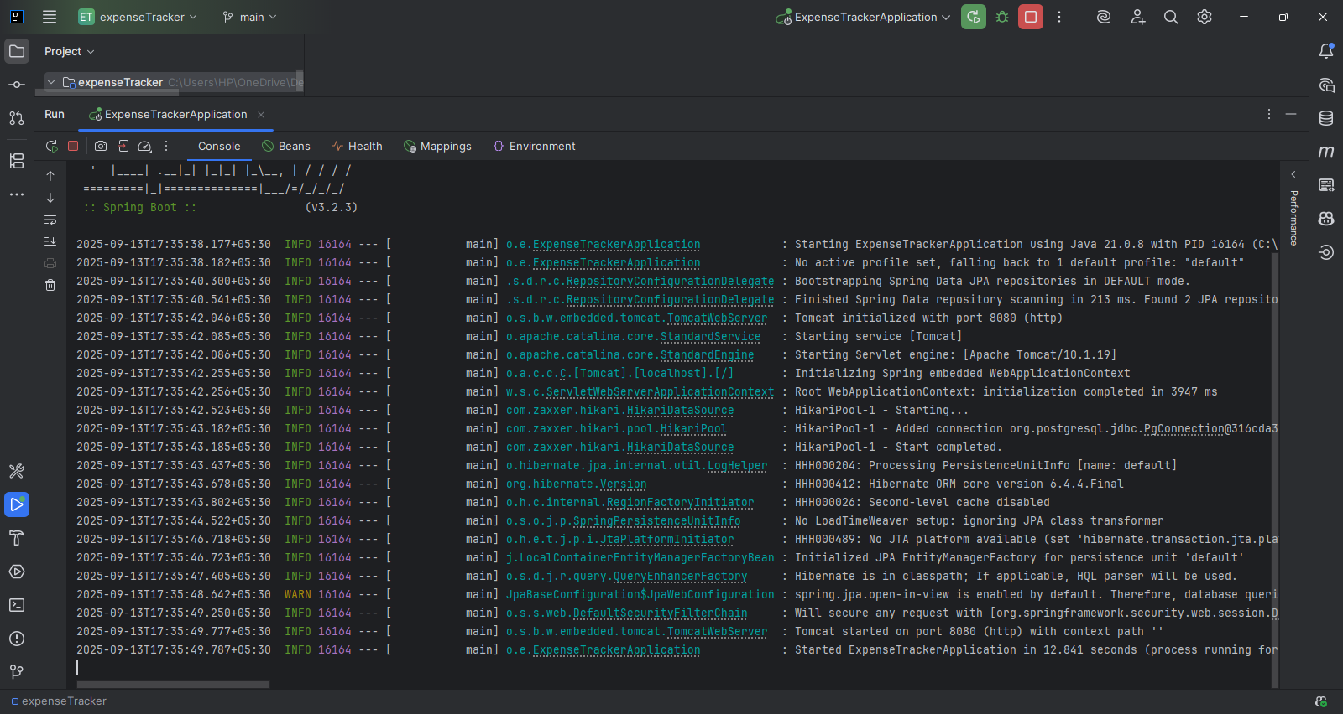

**Fig : Build Screen**

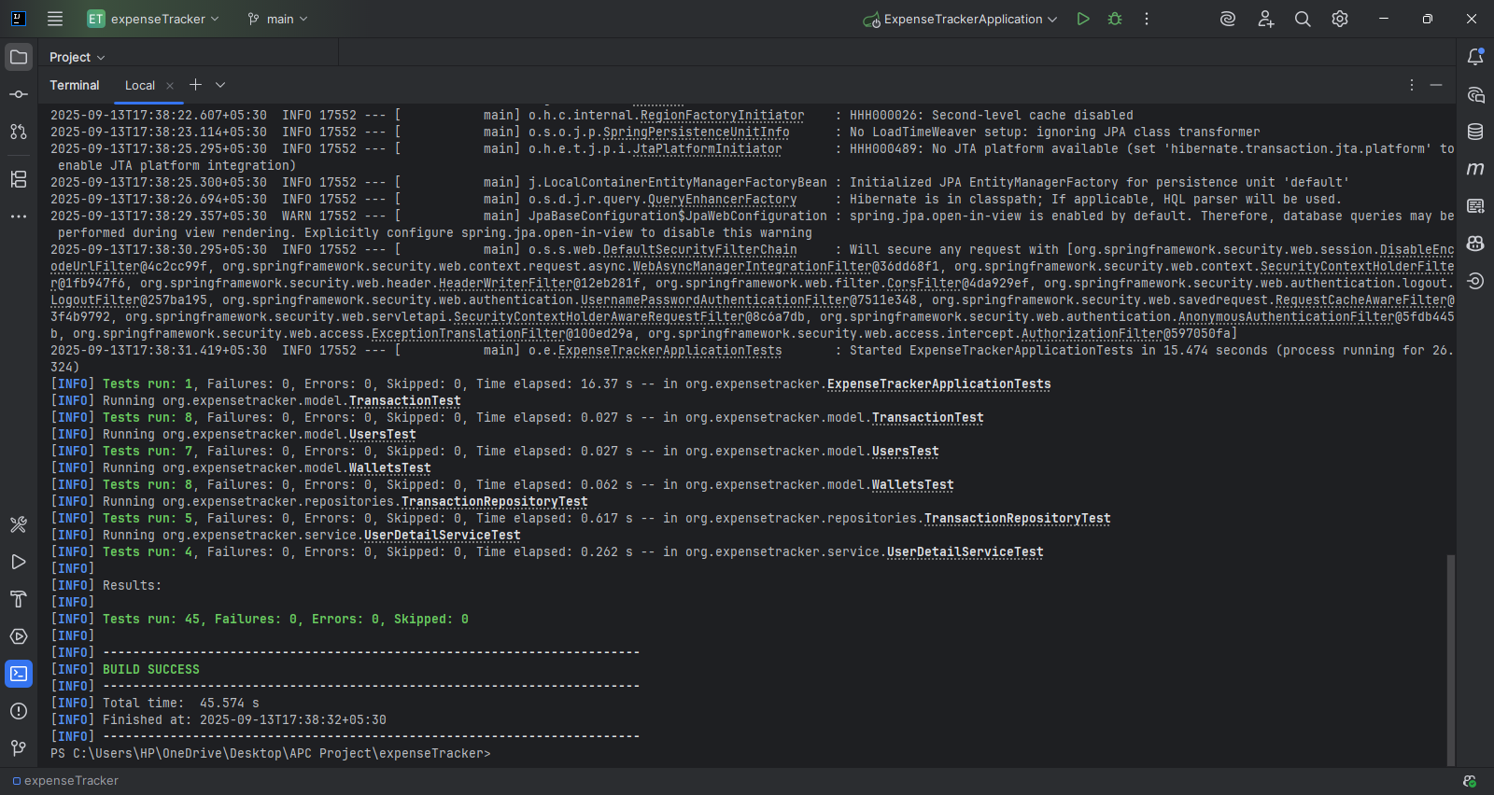

**Fig : Test Screen**

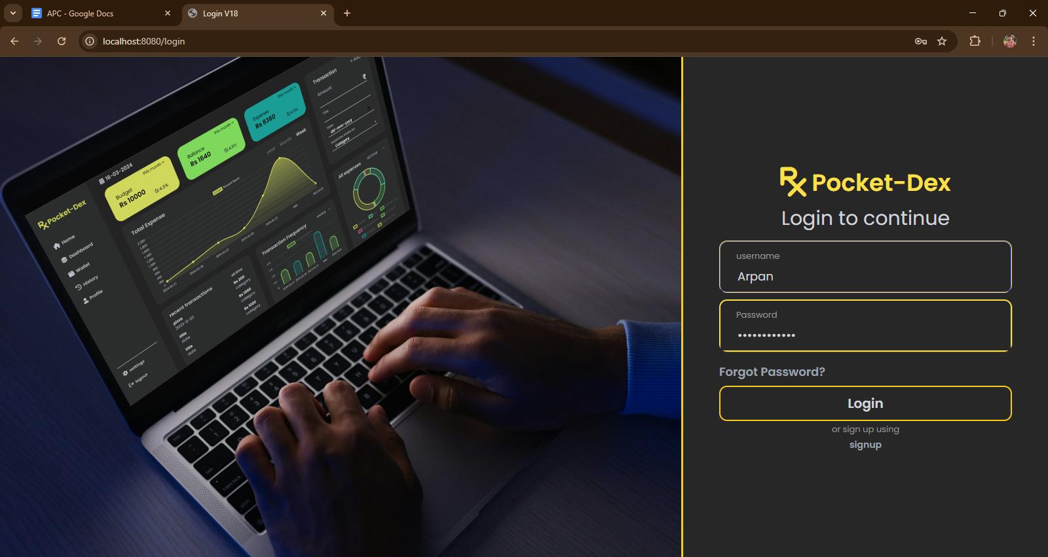

**Fig : Login Screen**

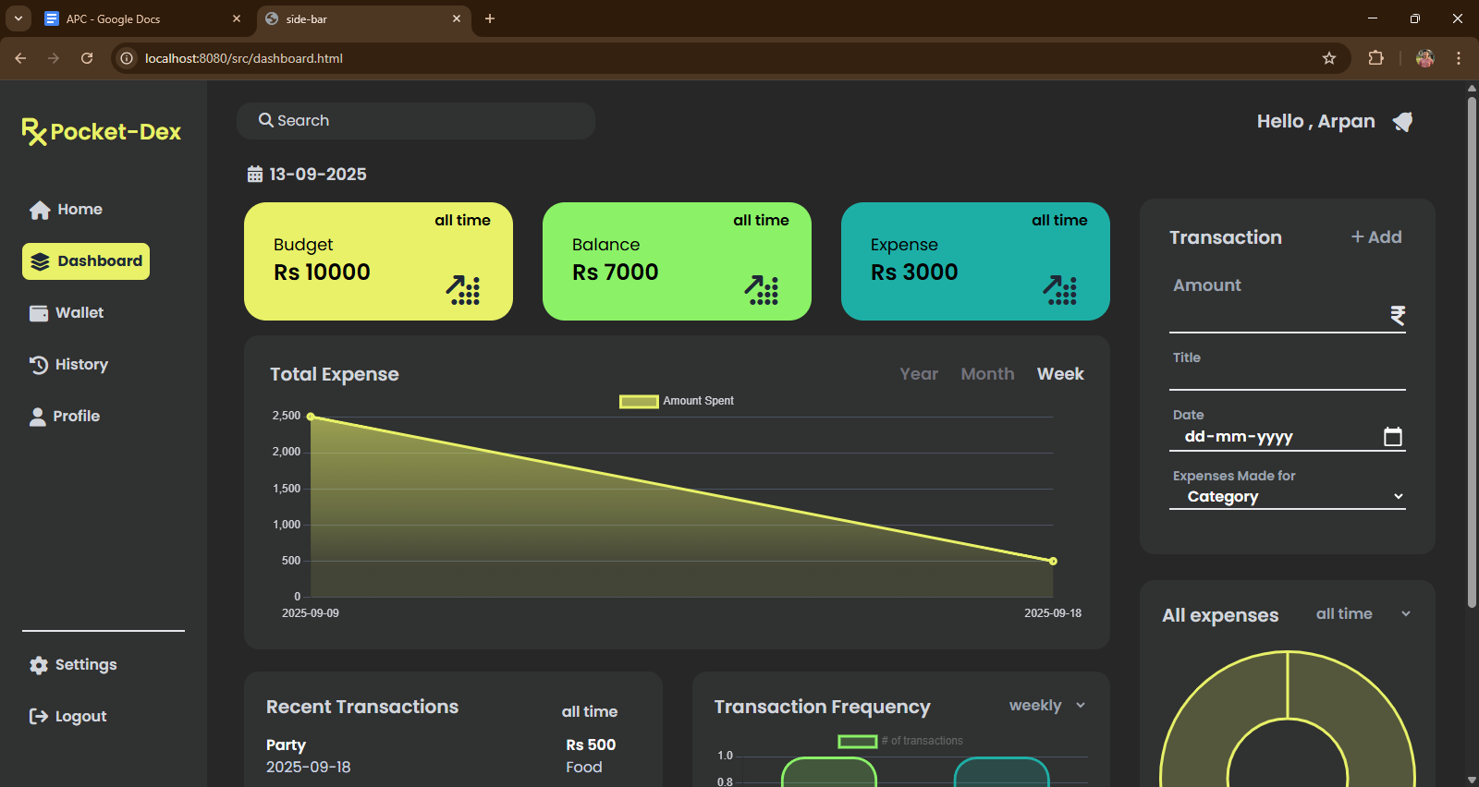

**Fig : Home Screen**

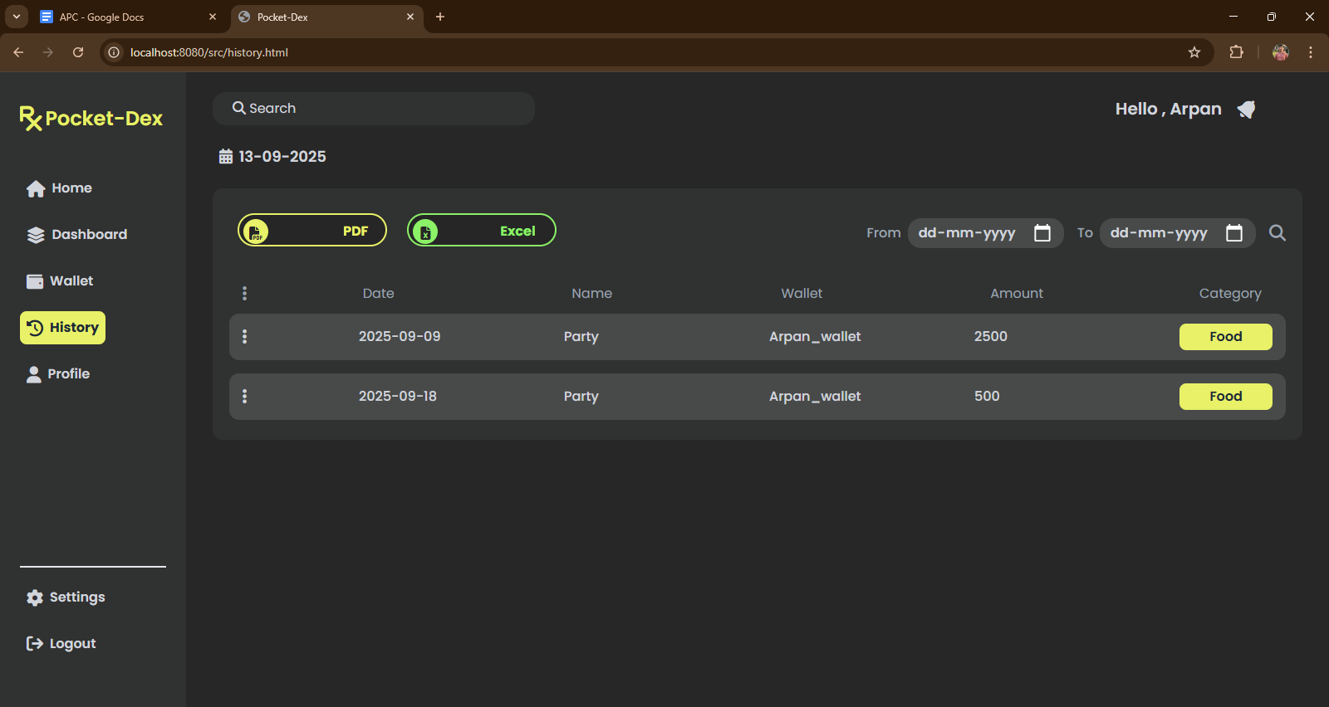

**Fig : History Screen**

**Future Scope**

The File Sharing Application has significant potential for expansion by integrating with cloud storage solutions such as AWS S3, Google Drive, or Microsoft Azure, which would allow scalable, secure, and globally accessible file storage. Features like advanced search, AI-based file categorization, tagging, and metadata-driven organization can make file retrieval faster and more efficient, improving productivity for individual users and organizations alike.

Real-time collaboration features can be introduced, enabling multiple users to work on files simultaneously, track versions, and share workspaces, making the application suitable for team projects and enterprise environments. Additionally, mobile applications for iOS and Android can extend accessibility, allowing users to manage, upload, and share files seamlessly from their smartphones or tablets.

Security enhancements such as end-to-end encryption, multi-factor authentication, detailed activity logs, and permission-based access control can ensure robust data protection and compliance with industry standards. Other future improvements may include automated backup, file analytics, usage tracking, integration with productivity tools like calendars and project management apps, and AI-driven recommendations for organizing and managing files efficiently.

**Conclusion**

The File Manager Web Application effectively demonstrates a modern approach to managing digital files in a secure and user-friendly environment. By leveraging the power of React for a responsive frontend, Spring Boot for a robust backend, and MongoDB for efficient data storage, the project successfully integrates all layers of a full-stack application. The inclusion of Clerk authentication ensures that file access is personalized and secure, while features like file upload, download, deletion, and public/private visibility offer comprehensive file management capabilities.

The project emphasizes modularity, scalability, and maintainability in both frontend and backend code, allowing for future enhancements such as cloud storage integration, real-time collaboration, AI-powered file organization, and advanced analytics. This ensures the application can grow with user needs while maintaining high performance and reliability.

Overall, the project provides a practical solution for individuals and organizations, offering a secure, organized, and efficient method for managing, sharing, and accessing digital files, making it a valuable tool in today’s data-driven environment.